|  |  |
| --- | --- |
|  | HOUSING REAL-ESTATE INVESTMENTS- Tech-emerging cities in India |
|  |  |
|  | KESIRAJU TEJASWINI  4/6/23 |

Table of Contents

ABSTRACT1

INTRODUCTION1

OBJECTIVES1

RESEARCH METHODOLOGY1

ANALYSIS …………………………………………………………………………………………………………………………………………. 2

PRICE INSIGHTS………………………………………………………………………………………………………………… 2

SIZE INSIGHTS…………………………………………………………………………………………………………………… 5

PRICE – SIZE RELATION……………………………………………………………………………………………………… 6

TYPES OF PROPERTIES………………………………………………………………………………………………………. 7

FURNISHED, SEMI-FURNISHED, UNFURNISHED…………………………………………………………………. 8

READY TO MOVE IN PROPERTIES……………………………………………………………………………………… 9

RERA REGISTERED……………………………………………………………………………………………………………. 9

NUMBER OF BED ROOMS ……………………………………………………………………………………………. 10

ALL INVESTMENTS AT ONE PLACE …………………………………………………………………………………. 11

CONCLUSIONS………………………………………………………………………………………………………………………………. 12

1. ABSTRACT:

The Indian real-estate industry has witnessed a boom from the year 2002, almost a decade after the introduction of economic reforms in 1991. Post-liberalization India has termed to be a hotspot for foreign direct investments, new ventures, Indian companies have also increased immensely. This growing demand in India is one of the key reasons behind the sky rocketing prices of real-estate investments. Especially, cities such as Bangalore, Hyderabad, Chennai, Delhi, Mumbai, Kolkata, Lucknow have showed many trends over the last few years. For an average Indian investment made in housing or properties are one-time investments and before investing one considers several factors and purpose of investment also varies from one investor to another investor.

1. INTRODUCTION:

In 2022, Indian real-estate market is values at $2.5 Billion dollars. NITI Aayog expects that the Indian real estate industry will one trillion dollars by 2030 and will account for 13 per cent of India’s GDP by 2025. In the first half of 2022, around 44 thousand housing units were sold in Mumbai, India's most demanding residential housing market. All of the eight biggest metropolitan areas of India recorded a significant increase in housing sales. There was a total of 158,705 residential property sold during the period.

1. OBJECTIVES:

* To provide price insights and dividing the price range into three groups (High, Mid, low)
* To provide size insights
* To examine the relation between the size and price
* To study about different types of properties in tech- emerging cities, number of furnished, semi-furnished and unfurnished properties and the number of ready to move properties for lease in tech-emerging cities
* To know other insights about RERA (Real Estate Regulatory Authority) listed properties, number of bedrooms, city that has highest number of properties etc.
* To know the potential localities for investors who want to make all investments at one place and for others in another place

1. RESEARCH METHODOLOGY:

Data and information are the two most important pillars of any analysis and they must be collected from verified sources for carrying out the analysis efficiently. The present study is of analytical and exploratory nature. Only secondary data is used in this study. The secondary data is collected from ‘Makaan.com’ – a one-stop real estate platform. It is a technology start-up driven to disrupt the real estate market by taking a fresh, new take on the sector.

The analysis is done in R studio, an IDE (Integrated Development Environment) for R programming language which is primarily used for statistical analysis and data visualization, Python and excel are also used for carrying the analysis. This study is only limited to tech-emerging cities in India namely Ahmedabad, Bangalore, Chennai, Delhi, Hyderabad, Kolkata, Lucknow and Mumbai.

SAMPLE SIZE:

The dataset is a real dataset containing data from Makaan.com. To view or download the dataset [click here](https://iiitaphyd-my.sharepoint.com/:x:/g/personal/vipul_chhabra_research_iiit_ac_in/EQ62devsuhpCqknByjZ0tzkBhmkiXGGN2d10unWr152e9g?rtime=RxCup3PY2kg) (as on August 2022).

The dataset has a total of 1,43,708 rows and 33 columns.

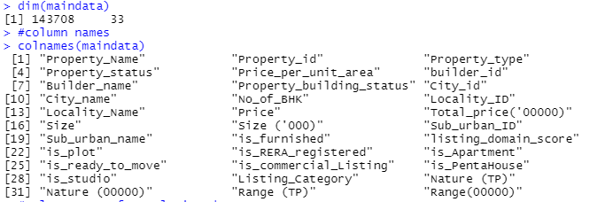

1. PRICE INSIGHTS

Price is one of the keys and an important determinant while investing in any property. Therefore, understanding all the parameters about the price is really important.

5.1 PRICE INSIGHTS IN TECH EMERGING CITIES

Summary insights of all eight tech emerging cities



The average property price is 136.23 (in Lakhs).

Price range classification-

|  |  |
| --- | --- |
| Nature of price | Range of price (in Lakhs) |
| HIGH | 154.80 to 8000.00 |
| MID | 85.00 to 154.80 |
| LOW | 0.00 to 85.00 |

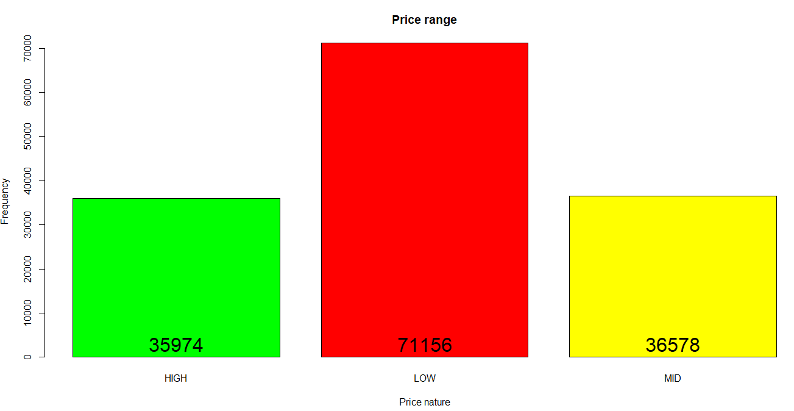

When considering all the eight cities, there are 71,156 properties which fall are of Low-priced nature (whose price ranges between 1,00,000 to 85,00,000 rupees) and there are 35,974 properties which are high priced (whose price ranges between 85,00,001 to 1,54,80,000 rupees) and 36,578 properties that fall in between (whose price ranges between 1,54,80,001 to 80,00,00,000 rupees).

Price-City insights:

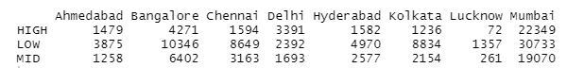

Mumbai has highest numbers properties in all three price ranges (High, Low, Mid) and followed by Bangalore. Kolkata has highest number Low price range properties after Mumbai and Bangalore.

5.2 TOTAL PRICE

Average total price is highest in Delhi and lowest in Lucknow. The minimum total price is highest in Lucknow and lowest in Kolkata. The minimum total price is highest in Lucknow and lowest in Kolkata. The maximum total price is highest in Mumbai and lowest in Lucknow.

So, if an investor wants to invest/buy a property in the city where prices are low Lucknow and Kolkata then followed by Hyderabad and Chennai would be two potential cities from both price and technology point of view. On an average Bangalore, Mumbai and Ahmedabad have highly priced properties which will costs investors few extra bucks.

|  |  |  |  |
| --- | --- | --- | --- |
| **CITY** | **Average Total price (in lakhs)** | **Minimum Total price (in lakhs)** | **Maximum Total price (in lakhs)** |
| Ahmedabad | 124.6767021 | 2.8 | 3800 |
| Bangalore | 130.1062233 | 1.35 | 3149.99776 |
| Chennai | 92.7755848 | 2.6 | 1846.2 |
| Delhi | 161.0233884 | 5 | 4700 |
| Hyderabad | 115.4509258 | 1.44 | 6100 |
| Kolkata | 83.65123535 | 1 | 2500 |
| Lucknow | 65.7466818 | 4.408 | 435 |
| Mumbai | 158.3220946 | 2.2 | 8000 |

5.2 PRICE PER UNIT

Mumbai has highest average of price per unit area and Lucknow has lowest average of price per unit area. Delhi has highest minimum of price per unit property and Kolkata has lowest minimum of price per unit property. Mumbai has highest maximum of price per unit property and Lucknow as the lowest maximum of price per unit property.

|  |  |  |  |
| --- | --- | --- | --- |
| **CITY** | **Average Price per unit area** | **Minimum Price per unit area** | **Maximum of Price per unit area** |
| Ahmedabad | 5373.968537 | 212 | 49747 |
| Bangalore | 7030.863076 | 120 | 69162 |
| Chennai | 6137.574892 | 260 | 55859 |
| Delhi | 9350.546428 | 740 | 90000 |
| Hyderabad | 5516.007011 | 111 | 75001 |
| Kolkata | 5968.176211 | 104 | 67328 |
| Lucknow | 4275.186982 | 499 | 18510 |
| Mumbai | 14728.33852 | 211 | 99631 |

1. SIZE INSIGHTS

Size is another key determinant that will make or buy deal and studying all the parameters relating to size are important.

6.1 SIZE INSIGHTS IN TECH EMERGING CITIES:

Summary insights of all eight tech emerging cities



The average size of properties in all the eight cities is 1278 sq. Feet

Average size of the property is highest in Ahmedabad and is the lowest in Mumbai. Hyderabad has the lowest sized property and Kolkata has highest sized property.

|  |  |  |  |
| --- | --- | --- | --- |
| **CITY** | **Average Size**  **(In thousands)** | **Minimum Size**  **(In thousands)** | **Maximum Size**  **(In thousands)** |
| Ahmedabad | 2.068436177 | 0.15 | 90 |
| Bangalore | 1.651908273 | 0.231 | 17 |
| Chennai | 1.381724303 | 0.177 | 11.872 |
| Delhi | 1.468697298 | 0.15 | 11 |
| Hyderabad | 1.992287545 | 0.1 | 27 |
| Kolkata | 1.261794012 | 0.113 | 34.56 |
| Lucknow | 1.503844379 | 0.3 | 10 |
| Mumbai | 0.964555854 | 0.127 | 20 |

If an investor wants to target cities by the size of the properties Ahmedabad, Hyderabad and Bangalore are three good options for investments.

1. PRICE – SIZE RELATION

The total price will marginally increase with an increase in the size of the property.  According to diminishing marginal utility, when the house size reaches the optimal size of the investor, the willingness to pay the price will start declining. The total price is not entirely determined by the size but also is influenced by various other factors. The total price will marginally increase with an increase in the size of the property.  According to diminishing marginal utility, when the house size reaches the optimal size of the investor, the willingness to pay the price will start declining. The total price is not entirely determined by the size but also is influenced by various other factors.

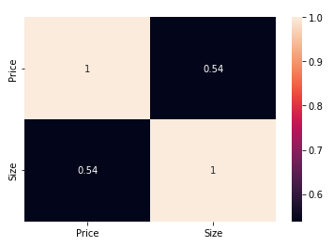

There is a positive correlative between the price and size in all the eight cities. Which implies when the size of the property increases, the price also increases and when the size of the property decreases, the price also decreases.

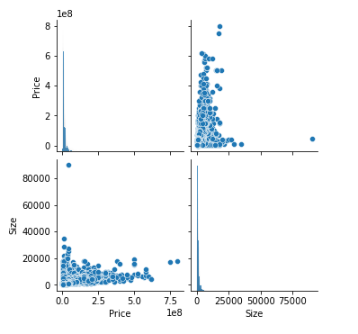

The correlation heatmap establishes that price and the size of the property are moderately correlated.

1. DIFFERENT TYPES OF PROPERTIES IN TECH-EMERGING CITIES

Different investors may need different type of property for different purposes. There are different types of properties such as apartment, independent floor, independent house, residential plot, villa. The following visualization provides insights on number of different types of properties in all the cities combined.

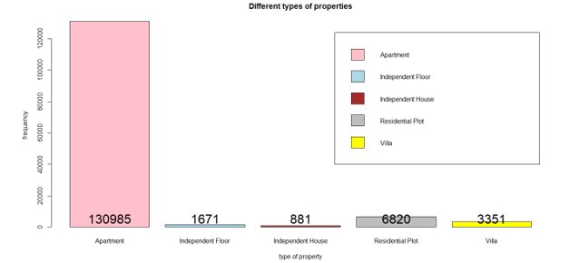

There are 1,30,985 apartments, which is the highest and followed by residential plots which are around 6,800.

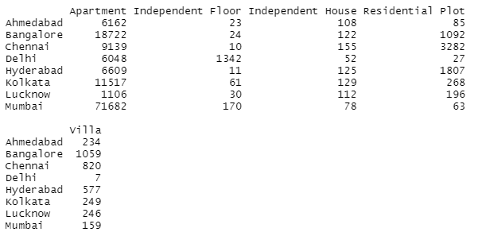

Apartments are the highest in all cities, Mumbai have highest number of apartments and then followed by Bangalore. Chennai has highest and Delhi has least number of residential plots. Delhi has highest number of independent floors and least number of villas and independent houses.

1. NUMBER OF FURNISHED, SEMI-FURNISHED, UNFURNISHED PROPERTIES

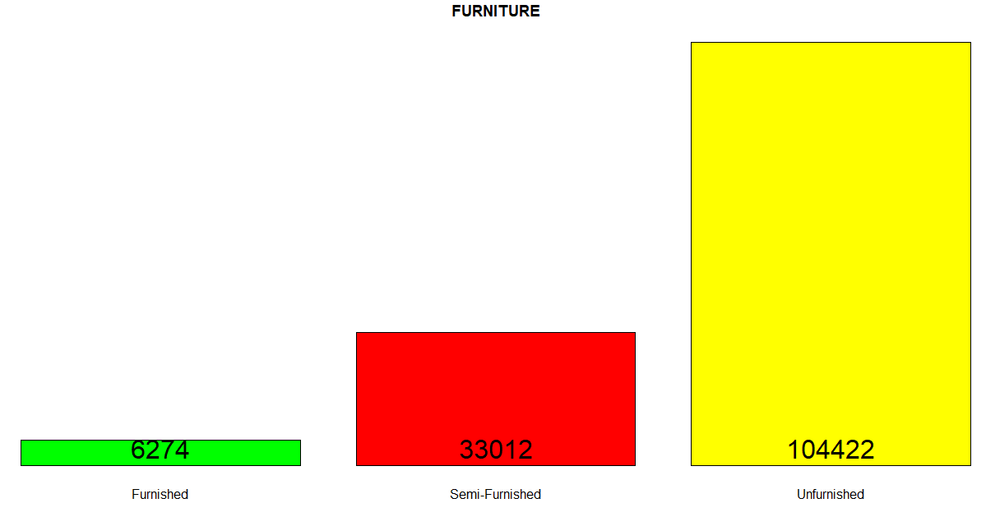

There are 1,04,422 unfurnished properties, 33,012 semi furnished properties and only 6,274 furnished properties in all cities combined.

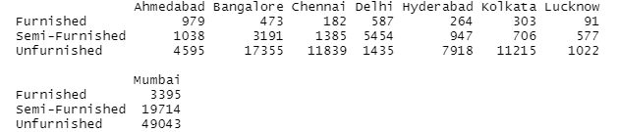

Mumbai has highest number of Furnished, semi-furnished and unfurnished properties. Next, Bangalore has highest number of unfurnished properties. Ahmedabad has highest number of furnished properties after Mumbai.

1. NUMBER OF READY TO MOVE IN PROPERTIES

Sometimes investors want ready to move properties to meet their immediate requirements.

The below visualization shows the number of ready to move properties in all cities combined.

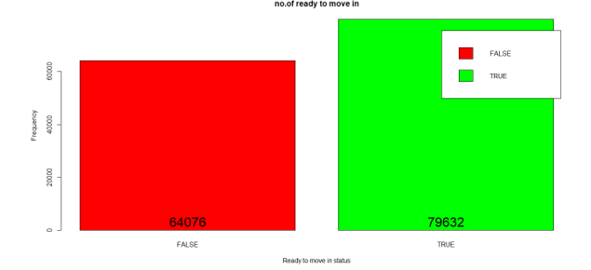

There are a total 79,632 ready to move properties and 64,076 properties in under construction



Mumbai has highest number of ready to move in properties followed by Bangalore and Chennai.

1. RERA REGISTERED PROPERTIES

RERA (Real Estate Regulatory Authority) which seeks to protect home-buyers as well as helps to boost investments in real-estate industry. The below visualisation shows the number of RERA registered properties in all the cities combined.

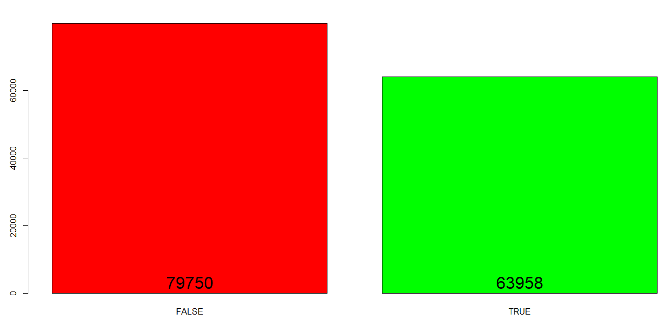

There are only 63,958 properties out of 1,43,708 properties which are RERA registered in all cities combined.



Mumbai, Bangalore has highest number of properties registered under RERA.

1. BED ROOMS

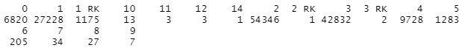

When we look insights of all the cities, there are more two and three bed roomed properties

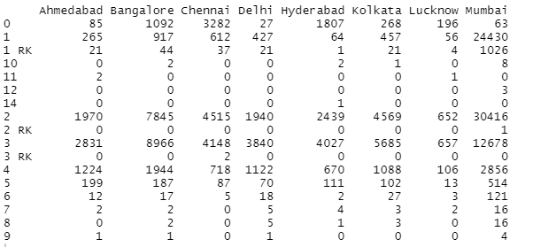

Mumbai has highest number of three, two and one bed roomed properties.

1. POTENTIAL PLACES FOR INVESTORS WHO WANT TO MAKE ALL INVESTMENTS AT ONE PLACE

Sometimes investors want to purchase one or more properties at one particular locality for commercial purposes. Hence knowing the number of properties at each place is useful.

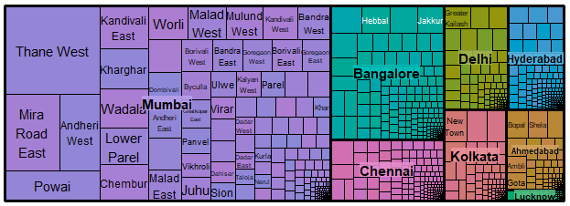

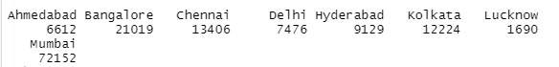

If an investor wants to invest at one place Mumbai, Bangalore and Chennai can be three potential places for investing.

CONCLUSIONS:

1. When the budget range is divided into three budget groups, we can see that the maximum number of properties fall under the low-price nature [i.e., <85 * 1,00,000] and mid & high-priced properties are around 36,000 & 35,000 respectively. The average property price is 136.23 (in lakhs). Mumbai has the highest number of properties in all three price ranges and is followed by Bangalore.
2. The average size of the property is highest in Ahmedabad and the lowest in Mumbai. Hyderabad has the lowest-sized property and Kolkata has the highest sized property.  The average size of properties in all eight cities is 1278 sq. Feet
3. There is a positive correlation between the price and size in all eight cities. This implies, when the size of the property increases, the price also increases and when the size of the property decreases, the price also decreases.
4. On the whole, there are around 1,30,000 apartments in all the cities, the next highest being for residential plots. By analyzing the group bar plot, we can tell Mumbai has the highest number of apartments compared to other cities and is next followed by Bangalore. Delhi has the highest number of independent floor properties and the least number of independent house properties.
5. Mumbai records the highest number of furnished, semi-furnished, as well as un-furnished properties.
6. There are a total of 79,632 ready-to-move properties in all the cities. When we analyze the city-wise data, we can say that Mumbai records the highest number of ready-to-move properties with around 40,000 properties, followed by Bangalore with around 10,000 properties.
7. By seeing the graphs, we can tell that the major number of properties are not registered with a RERA, and the majority of the properties are 2 BHKs. Mumbai has a total overall number of properties and is followed by Bangalore.
8. By seeing the tree map, we can say that an investor can make a maximum number of investments in one place, which is in ‘Mumbai’, and the least number of investments in one place, which is ‘Lucknow’.